HK INSTITUTE OF VOCATIONAL EDUCATION
DEPARTMENT OF INFORMATION AND COMMUNICATIONS TECHNOLOGY

ITP4910 Software Development Project

LAB 10 – Modifying the data in a database

Objectives:
- To navigate the data in a database without a BindingNavigator control.
- To modify the data in a database without a BindingNavigator control.

The BindingNavigator control represents a standardized way to navigate and manipulate data on a form. By default, the BindingNavigator control's user interface (UI) is composed of a series of ToolStrip buttons, text boxes, and static text elements for most common data-related actions, such as adding data, deleting data, and navigating through data. It is easy to modify the database with these ToolStrip buttons and all the code are generated automatically. However, in some cases the use of a BindingNavigator control may not be appropriate because we do not want the user to access all records by the BindingNavigator control. In this laboratory, we would explore some ways in modifying the database without using the BindingNavigator controls.

Part A Navigating records in a database

- Download a database ITP4910-Lab10-DB.zip.

- Create a new project of type Windows Applications. Enter Lab10 as its name. Unzip the Lib.accdb database files and place them inside the Debug directory of your application.

- Following the similar steps in previous laboratories, add a data source to your Form. Choose all tables and name the DataSet libDataSet.

- In the Data Sources window, set the mode of the Books node to Details using the drop-down list. Drag the Books node onto the Form1 design surface. This will add seven text boxes with labels onto the form and will also add a BooksBindingSource, a BooksBindingNavigator, a LibDataSet and a BooksTableAdapter to the form.

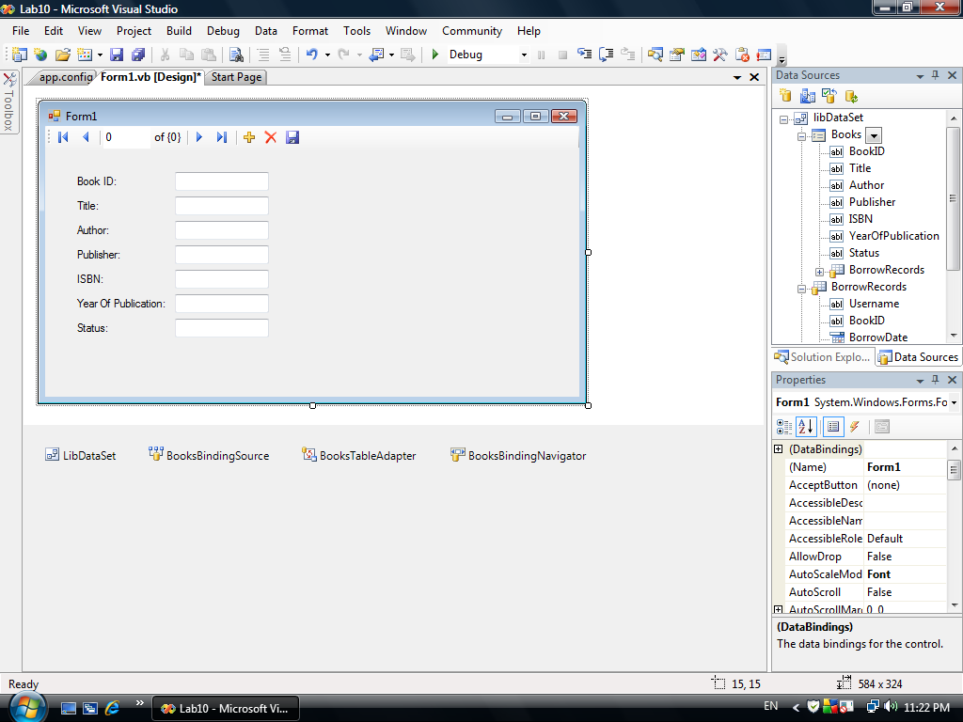

Hint : The BindingNavigator is used here to facilitate the generation of the DataSet, BindingSource and TableAdapter to the form. It will be set invisible later. The DataSet, BindingSource and TableAdpater can also be created using other methods which we have learnt in previous laboratories. The method will also be revisited in Part B.

- Set the Visible property of the BooksBindingNavigator to false. Run the program to see if the data of the Books table can be displayed correctly. As the BooksBindingNavigator is not visible, you cannot use the buttons on it.

- Create four buttons as follows.

Object | Property | Setting
Button | Name  Text | btnPrevious  &Previous
Button | Name  Text | btnNext  &Next
Button | Name  Text | btnFirst  &First
Button | Name  Text | btnLast  &Last
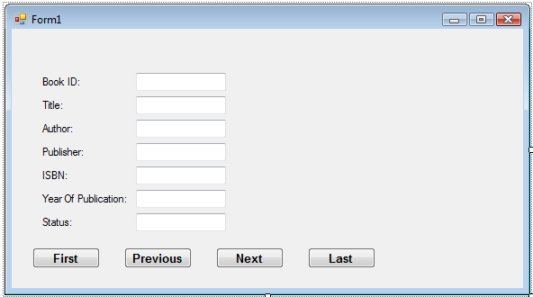

- Add code for the event btnFirst_Click.

private void btnFirst_Click(object sender, EventArgs e) {
booksBindingSource.Position = 0;
}

Hint : The value of the BooksBindingSource.position is used to control the record to be displayed

- Add code for the event btnLast_Click.

private void btnLast_Click(object sender, EventArgs e) {
booksBindingSource.Position =
libDataSet.Books.Rows.Count - 1;
}

- Add code for the event btnNext_Click.

private void btnNext_Click(object sender, EventArgs e) {
if (booksBindingSource.Position < libDataSet.Books.Rows.Count - 1)
booksBindingSource.Position++;
}

- Add code for the event btnPrevious_Click.

private void nPrevious_Click(object sender, EventArgs e) {
if (booksBindingSource.Position > 0)
booksBindingSource.Position--;
}

- Run the program to see if the four buttons work appropriately.

Part B: Modifying records in a database

Updating and deleting records in a database

- Add three buttons, one label and one combo box on Form 1.
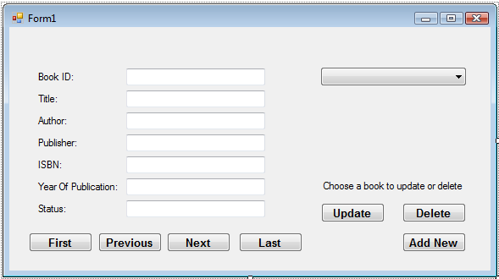

Properties Table

Object | Property | Setting
Label | Name  Text | lblMessage  Choose a book to update or delete.
Button | Name  Text | btnUpdate  Update
Button | Name  Text | btnDelete  Delete
Button | Name  Text | btnInsert  Add New
Combo Box | Name  BackColor  DropDownStyle  DataSource  DisplayMember | cboTitle  Info  DropDownList  BooksBindingSource  Title

- Add code for the event cboTitle_SelectedValueChanged.

private void cboTitle_SelectedValueChanged(...) {
booksBindingSource.Position = cboTitle.SelectedIndex;
}

Hint : The above procedure is used to locate index of the record that has been chosen.

- Add code for the event btnDelete_Click

private void btnDelete_Click(object sender, EventArgs e) {
libDataSet.Books.Rows[booksBindingSource.Position].Delete();
}

Hint : The statement

libDataSet.Books.Rows[booksBindingSource.Position].Delete();

is used to delete the record at the index 1 in the Books table if the value of BooksBindingSource is 1.

- Click on the ComboBox and select the book Telecommunications. Click on the Delete button. Check the database file to see if the modification and deletion are effective.

- It is a good practice to let the user confirm before the record is deleted. So modify the code for the event btnDelete_Click to use a MessageBox asking whether the user would like to really delete the record or not. Modify the code for the event btnDelete_Click as follows.

private void btnDelete_Click(object sender, EventArgs e) {
if (MessageBox.Show(
"Do you really want to delete the record?",
"Close", MessageBoxButtons.YesNo,
MessageBoxIcon.Exclamation,
MessageBoxDefaultButton.Button1) == DialogResult.Yes) {

int pos = booksBindingSource.Position;
Try {
libDataSet.Books.Rows[booksBindingSource.Position].Delete();
booksTableAdapter.Update(libDataSet.Books);
}
catch (Exception ex) {
MessageBox.Show(ex.Message, "Error");
booksTableAdapter.Fill(libDataSet.Books);
booksBindingSource.Position = pos;
}
}
}

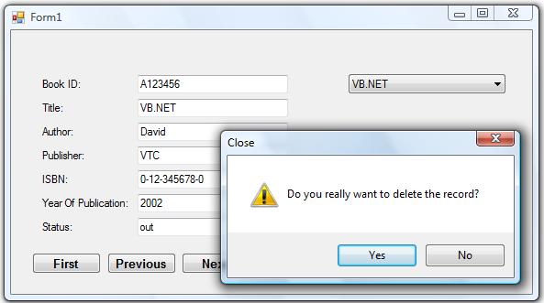

Hint :
- The statement

MessageBox.Show("Do you really want to delete the record?",
"Close", MessageBoxButtons.YesNo, MessageBoxIcon.Exclamation,
MessageBoxDefaultButton.Button1)

is used to check whether the user has clicked on the Yes button or the No button.
- Remember that some records cannot be deleted and hence the try .. catch block is employed to show the error message.

- Add code for the event btnUpdate_Click.

private void btnUpdate_Click(object sender, EventArgs e) {
int pos = booksBindingSource.Position;
try {
booksBindingSource.EndEdit();
booksTableAdapter.Update(libDataSet.Books);
}
catch (Exception ex) {
MessageBox.Show(ex.Message, "Error");
booksBindingSource.CancelEdit();
}
}

- Run the program. Click on the ComboBox and select the book What’s JSP. Modify the YearOfPublication to 2002 and click on the Update button.

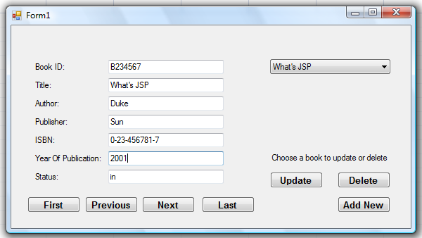
Adding new records to a database

- Add a new form Form2 with text Add New. Add the controls with names and texts as in the following table.

Object | Property | Setting
Label | Name  Text | lblBookID  Book ID :
Label | Name  Text | lblAuthor  Author :
Label | Name  Text | lblTitle  Title :
Label | Name  Text | lblPublisher  Publisher :
Label | Name  Text | lblISBN  ISBN :
Label | Name  Text | lblYearOfPublication  Year Of Publication :
Label | Name  Text | lblStatus  Status :
Text Box | Name  Modifiers  Text | txtBookID  Internal
Text Box | Name  Modifiers  Text | txtAuthor  Internal
Text Box | Name  Modifiers  Text | txtTitle  Internal
Text Box | Name  Modifiers  Text | txtPublisher  Internal
Text Box | Name  Modifiers  Text | txtISBN  Internal
Text Box | Name  Modifiers  Text | txtYearOfPublication  Internal
Text Box | Name  Modifiers  Text | txtStatus  Internal
Button | Name  Text  DialogResult | btnAdd  Add New  OK
Button | Name  Text  DialogResult | btnCancel  Cancel  Cancel

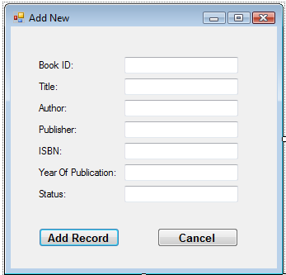

- Set the AcceptButton and CancelButton of Form2 to btnAdd and btnCancel respectively.

- Add code for two get methods and the btnInsert_Click event of Form1.

private void btnInsert_Click(object sender, EventArgs e) {
try {
Form2 frm2 = new Form2();
if (frm2.ShowDialog() == DialogResult.OK) {
libDataSet.BooksRow row = libDataSet.Books.NewBooksRow();

row.SetField("BookID", frm2.txtBookID.Text);
row.SetField("Title", frm2.txtTitle.Text);
row.SetField("Author", frm2.txtAuthor.Text);
row.SetField("Publisher", frm2.txtPublisher.Text);
row.SetField("ISBN", frm2.txtISBN.Text);
row.SetField("YearOfPublication",
frm2.txtYearOfPublication.Text);
row.SetField("Status", frm2.txtStatus.Text);

libDataSet.Books.AddBooksRow(row);
booksTableAdapter.Update(libDataSet.Books);
MessageBox.Show("One new record was added successfully.");
}
else
MessageBox.Show("No new record was added.");
}
catch (Exception ex) {
MessageBox.Show(ex.Message + "\nNo new record was added.");
}
}

Hint :
- The statement
libDataSet.Books.AddBooksRow(row)
is used to add a new record to the Books table.

- The database management system will not permit records with duplicate primary key to be added. Hence the Try .. Catch block is used to display the error.

- Add code for the btnAdd_Click event of Form2.

private void btnAdd_Click(object sender, EventArgs e) {
Close();
}

- Add code for the btnCancel_Click event of Form2.

private void btnCancel_Click(object sender, EventArgs e) {
Close();
}

- Run the program and try to add the following record.

BookID: D112222
Title : Programming
Author : Tommy
Publisher: VTC
ISBN: 1-22-333333-0
YearOfPublication : 2009
Status: in

- Test the Add New button and Cancel button with other records. Check your database to verify if the additions are effective or not.

